Outreach activity:
Protein superglue to build vaccines

Howarth lab http://www.howarthgroup.org/ at Cambridge Festival,
https://www.festival.cam.ac.uk/
Saturday 23rd March 2024 10 am-4 pm
In Teaching labs of Department of Pathology, Tennis Court Road

Please feel free to use or adapt the figures and information in any way that is helpful.

Short description on website: Come along on an exciting journey into the world of super cool vaccines at our activity, " Protein superglue to build vaccines." We're here to tell you about SpyTag, a tiny tool that makes vaccines even better! We'll show you how SpyTag helps decorate protein nanoparticles and makes special antibodies that protect you from all kinds of bad germs. Plus, we'll use fun models, velcro, and show you awesome pictures.

Tabletop activities primarily aimed at families (age range 4 -14)

Thanks to the afternoon team at the Festival event.

Teaching goals
Explain in a hands-on and fun way:
• what a vaccine is
• how different viruses and bacteria may cause disease
• how vaccines can be built by assembling components of the pathogen
• how antibodies can stick to a virus and stop the virus causing disease
• how the body can make antibodies that are more sticky to the disease target after vaccination.

Where possible, we will also explain how the technology developed by the lab for virus-like particle assembly makes it easier to build new vaccines. This activity has been designed for young children, but there is no reason why it cannot be used all the way up to secondary school or undergraduate level to talk about concepts of the immune system and affinity.
Handout for visitors:

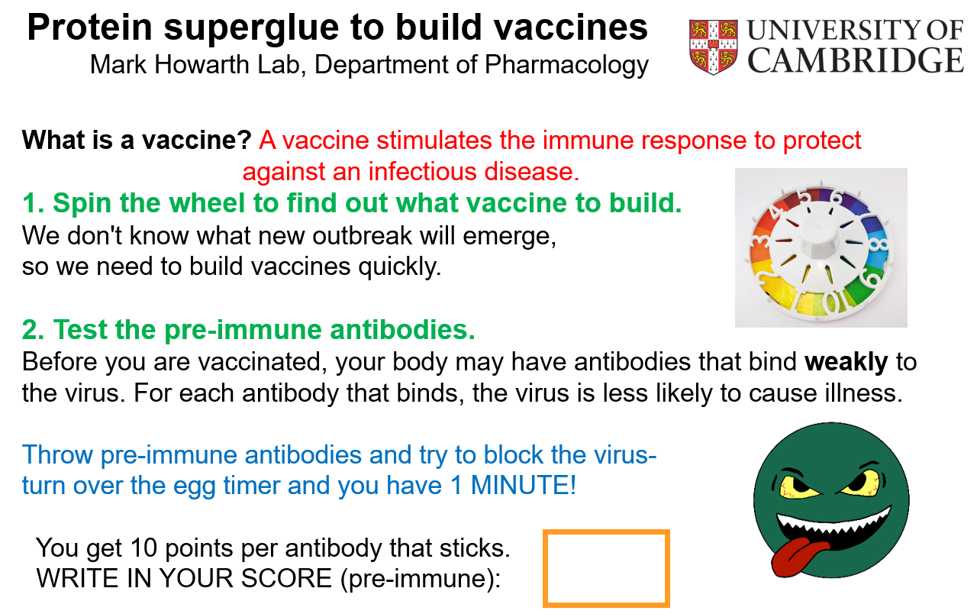
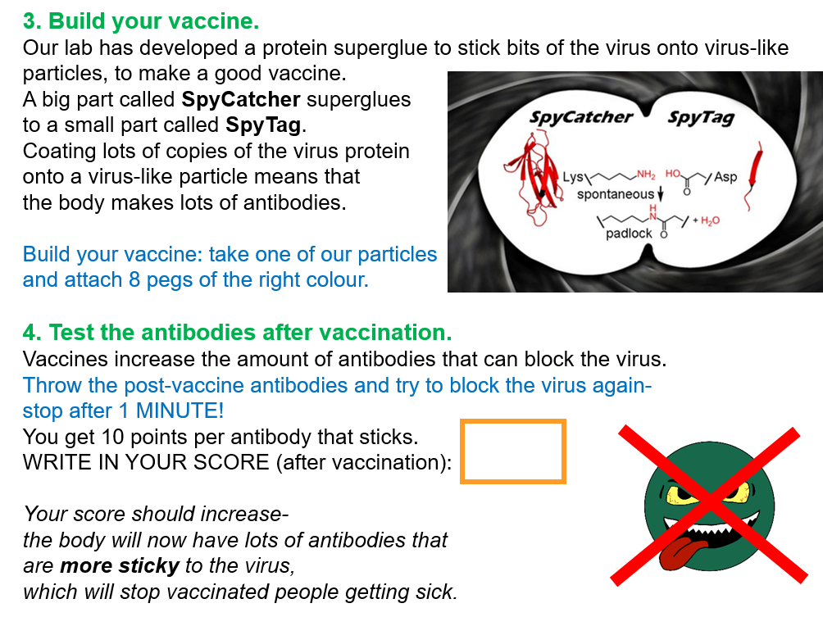

Things to make in advance

1. Antibodies
It is good to have about 30 “weak” antibodies and about 30 “strong” antibodies.
I went around Halfords testing small carpets with a strip of Velcro hooks and found some car mats with negligible sticking to Velcro hooks and some that were more fluffy and stuck excellently (sticking as well as real Velcro loops).
for high stick antibodies

Then I cut the mats (after paying…) with scissors into Y-shapes about 8 cm high. The Y-shape doesn’t need to be exact. It is helpful if the weak and strong antibodies look a little bit different (e.g. in the shade of grey or black) so they don’t get mixed up. We stored the antibodies in document boxes.
Only one side of the antibody stuck to the virus target.
Test things out by throwing the antibodies at your target, so you know how it behaves.
Our weak antibodies did stick occasionally, which was fine because it meant that the score was not 0 in the “pre-immune” sample.

2. Target
(i) Print poster A0 (see file on Howarth group website)
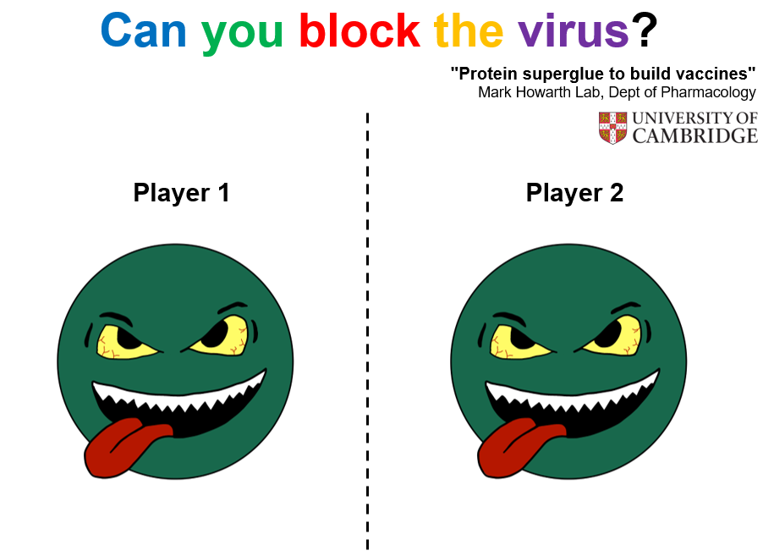
(ii) Cut strips of Velcro hooks on self-adhesive tape and stick around each virus, as though each strip is a spike protein. Sellotape Sticky Hook Strip 25 mm x 12 m 1445179, Yellow (e.g. on Amazon). Having lots of strips means that more throws are successful.

3. Pandemic spinner
I got the spinner from the Game of Life from a second hand shop and then the spinner was anchored to the poster (see file on Howarth group website).
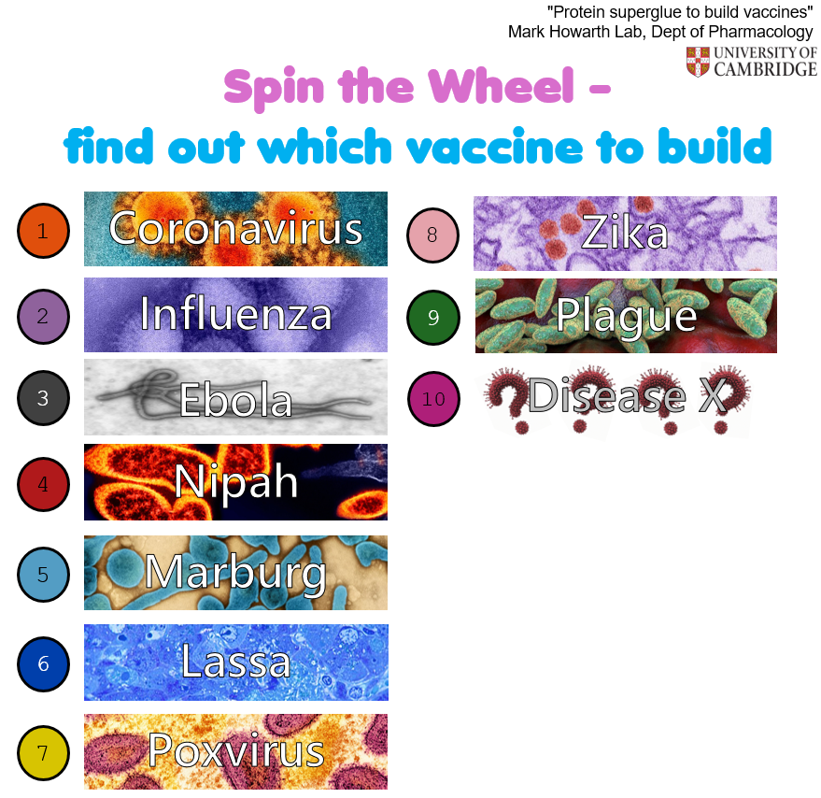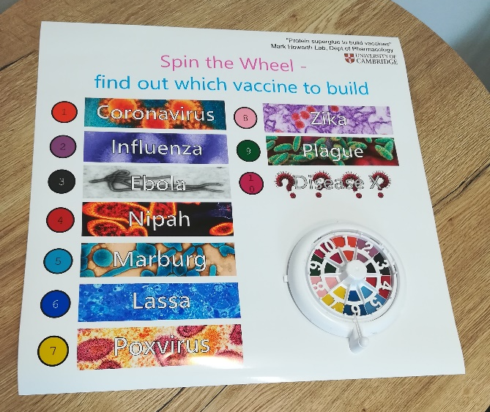

4. Virus-like particle models
(i) Pegs to represent the coupling of the antigen with SpyTag/SpyCatcher,
2 sets of Mini Wooden Pegs 100pcs Coloured Wooden Pegs 10 Colors Mini Wooden Clips 3.5cm (e.g. from Amazon)
(ii) twine balls to represent the virus-like particle
28 Pieces Christmas Rattan Balls Decorative Wicker Balls Christmas Tree Ornaments (e.g. from Amazon)
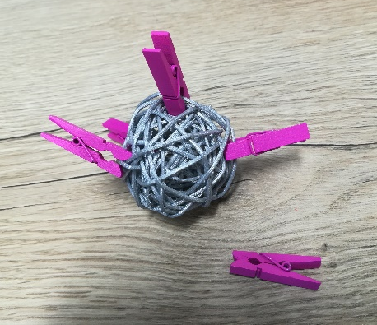

Other things to prepare:
• Poster board to pin up the scary virus target poster
• Two timers (timers that beep are ideal; best not to use a phone because someone may get anxious that photos are being taken).
It is good to start the 1 min throwing by “Ready, steady, go!”
and end “5,4,3,2,1, stop!” before the timer beeps.
• Print out many copies of the handout above, and encourage visitors to take away
• Pens for visitors to write their name on the handout
• Illustrative toys you may have e.g. plush toy of Streptococcus pyogenes or vaccine (each available from GIANT Microbes) or bat (e.g. from Amazon), 3D print of virus-like particle.
• Whiteboard with marker pens where there can be a leader-board of top scores
• A pad for visitor feedback
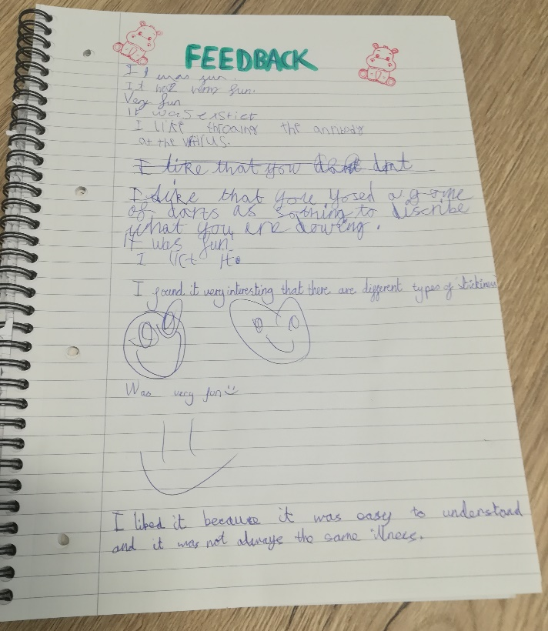
• Print-outs of relevant publication from the lab, in case one of the parents is a scientist.

Appendix

Information on specific viruses assembled from various internet sources by Rory Hills in case of questions:

- Coronavirus: Coronaviruses are a group of related viruses (enveloped single strand positive sense RNA). They are broken into alpha-, beta-, gamma- and delta-coronaviruses. There are seven coronaviruses known to infect humans. Four of these are viruses which can cause the “common cold”. These are NL63 and 229E which are alphacoronaviruses and OC43 and HKU1 which are betacoronaviruses. Three coronaviruses can be deadly to humans:
  - MERS-CoV which was identified in 2012. It has crossed over from camels to humans several times and has been detected in 27 countries.
  - SARS-CoV which caused the 2003 SARS epidemic which was first identified in Guangdong, China, in November 2002 and caused more than 750 deaths.
  - SARS-CoV-2 which caused the COVID-19 pandemic.
The name comes from the appearance of the virus which, when studied through an electron microscope, is reminiscent of the solar corona.
There are a several vaccines approved for SARS-CoV-2 that substantially reduce mortality and morbidity. There are vaccines in development for other coronaviruses. There is no approved pan-coronavirus vaccine.

- Influenza: Influenza viruses (enveloped negative sense single strand RNA) causes the “flu”. There are approximately 1 billion annual flu cases leading to approximately 290,000 to 650,000 deaths annually. The basic names for different flu viruses relate to the type of Hemagglutinin (H) and Neuraminidase (N). They have substantial pandemic potential with three global pandemics in the 20th century (1918 Spanish Flu, H1N1), (1957 Asian flu, H2N2), and (1968 Hong Kong Flu, H3N2).
The name “influenza” originated in 15th century Italy from "influenza di stelle", from an epidemic attributed to “influence of the stars.”
There are several approved influenza vaccines focussed on seasonal influenza strains. There are substantial fforts to develop more universal vaccines.

- Ebola: Ebola virus (enveloped negative sense single stranded RNA) that causes a type of hemorrhagic fever. It kills between 25% and 90% of those infected. It was first discovered in 1976. It is spread through contact with bodily fluids and can persist in immunologically privileged sites. Research is still being done to understand the animal reservoirs.
Ebola is named for the river in Africa where the disease was first recognized.
There are effective approved vaccines against the Zaire ebolavirus subspecies but not against other subspecies such as the Sudan virus.

- Nipah Virus: Nipah virus (enveloped single stranded RBD negative sense) is a zoonotic virus with a high fatality rate (40-75%). Outbreaks have been reported in Malaysia, Singapore, Bangladesh and India with this area being called the Nipah Belt. It was first discovered in 1998. Fruit bats, also called flying foxes, are the animal reservoir for NiV in nature.
Nipah virus was used as a basis for the pandemic in the 2011 Steven Soderbergh film Contagion.
Its name originated from Sungai Nipah, a village in the Malaysian Peninsula where pig farmers became ill with encephalitis.
There are no approved vaccines or treatments.

- Marburg: Marburg virus (enveloped, single-stranded, negative-sense RNA virus) is a zoonotic virus that causes a hemorrhagic fever similar to Ebola (they are part of the same virus family). The virus can be transmitted by exposure to fruit bats (Egyptian fruit bats have been identified as a reservoir) or it can be transmitted between people via body fluids through unprotected sex and broken skin.
Its name comes from the German city of Marburg, where there was an outbreak in 1967. It began when laboratory workers were exposed to tissues of infected grivet monkeys.
There are currently no vaccines or antiviral treatments approved to treat Marburg.

- Lassa: Lassa virus (enveloped single-stranded, negative-sense RNA virus) causes a hemorrhagic fever. It causes 400,000 cases per year with 5,000 deaths. Lassa virus commonly spreads to humans from other animals, specifically the African soft-furred mouse or African rat. Once the mouse has become a carrier, it will excrete the virus throughout the rest of its lifetime through feces and urine, creating ample opportunity for exposure.
The virus was identified in 1969 after 2 missionary nurses died from the disease in the Nigerian town of Lassa.
There is no approved vaccine.

- Poxvirus: Poxviruses are a family of viruses (double stranded DNA). Smallpox is a member of this family and was the first virus effectively eradicated by humans through a successful vaccination campaign. Evidence of smallpox infection has been seen in Egyptian mummies from 1100–1500 BCE. An estimated 300 million people were killed by small pox in the 20th century alone. Mpox (formerly called monkeypox) also infects humans and caused a notable outbreak in 2022. The virus has evolved to be more transmissible among humans and can infect a wide range of host species making it a substantial pandemic threat. Chickenpox is not a true poxvirus and is caused by the herpesvirus varicella zoster.

The origin of the word vaccine come from Latin vaccinus, from vacca ‘cow’ (because of the early use of the cowpox virus against smallpox). Edward Jenner demonstrated that infection with the much less dangerous cowpox provided protection against small pox. There have been several generations of effective small pox vaccines. There are effective mpox vaccines although further work is being done to improve their cost and efficacy.

- Zika: Zika virus (enveloped single stranded positive sense RNA virus) is transferred through mosquitos and causes Zika fever. In ~80% of cases Zika is asymptomatic but infection during pregnancy causes microcephaly and other brain malformations in some babies. Infection in adults has been linked to Guillain–Barré syndrome (GBS) (a rapid-onset muscle weakness caused by the immune system damaging the peripheral nervous system). Since the 1950s, Zika has been known to occur within a narrow equatorial belt from Africa to Asia. From 2007 to 2016, the virus spread eastward, across the Pacific Ocean to the Americas, leading to the 2015–2016 Zika virus epidemic.
Zika virus was first discovered in 1947 and is named after the Zika Forest in Uganda.
There is no approved vaccine or medicine.

- Plague: Plague is caused by the bacterium Yersinia pestis (anaerobic, Gram-negative). There are several different clinical manifestations of plague with the most common form being bubonic plague, followed by septicemic and pneumonic plague. Bubonic plague affects the lymph nodes, making them swell. Pneumonic plague infects the lungs, causing shortness of breath, coughing and chest pain. Septicemic plague infects the blood and can cause tissues to turn black and die. Transmission can occur from human-human or through vector borne transmission. Yersinia pestis circulates in animal reservoirs, particularly in rodents, and often spreads through fleas. Yersinia pestis was responsible for the Black Death (1346 to 1353) which killed at least 50 million people. An estimated 200 million deaths have been caused by plague. There are still ~600 cases a year.
Yersinia pestis was discovered in 1894 by Alexandre Yersin, a Swiss/French physician and bacteriologist from the Pasteur Institute. The first plague vaccine was identified in 1897 using inactivated bacteria. Live attenuated vaccines and recombinant protein vaccines have been developed to further improve efficacy. However, there is no currently licensed plague vaccine that meets modern clinical standards.

- Disease X: Disease X is the name given by scientists and the World Health Organization to an unknown pathogen that could emerge in future and cause a serious international epidemic or pandemic.

